**What is Inheritance ?**

Inheritance is an important aspect of the object-oriented paradigm. Inheritance provides code reusability to the program because we can use an existing class to create a new class instead of creating it from scratch.

In inheritance, the child class acquires the properties and can access all the data members and functions defined in the parent class. A child class can also provide its specific implementation to the functions of the parent class. In this section of the tutorial, we will discuss inheritance in detail.

In python, a derived class can inherit base class by just mentioning the base in the bracket after the derived class name. Consider the following syntax to inherit a base class into the derived class.

Python Inheritance

### Syntax

1. **class** derived-**class**(base **class**):
2. <**class**-suite>

A class can inherit multiple classes by mentioning all of them inside the bracket. Consider the following syntax.

**What are the types of Inheritance ?**

### ****Single Inheritance:****

Single inheritance enables a derived class to inherit properties from a single parent class, thus enabling code reusability and the addition of new features to existing code.

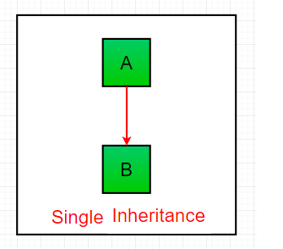

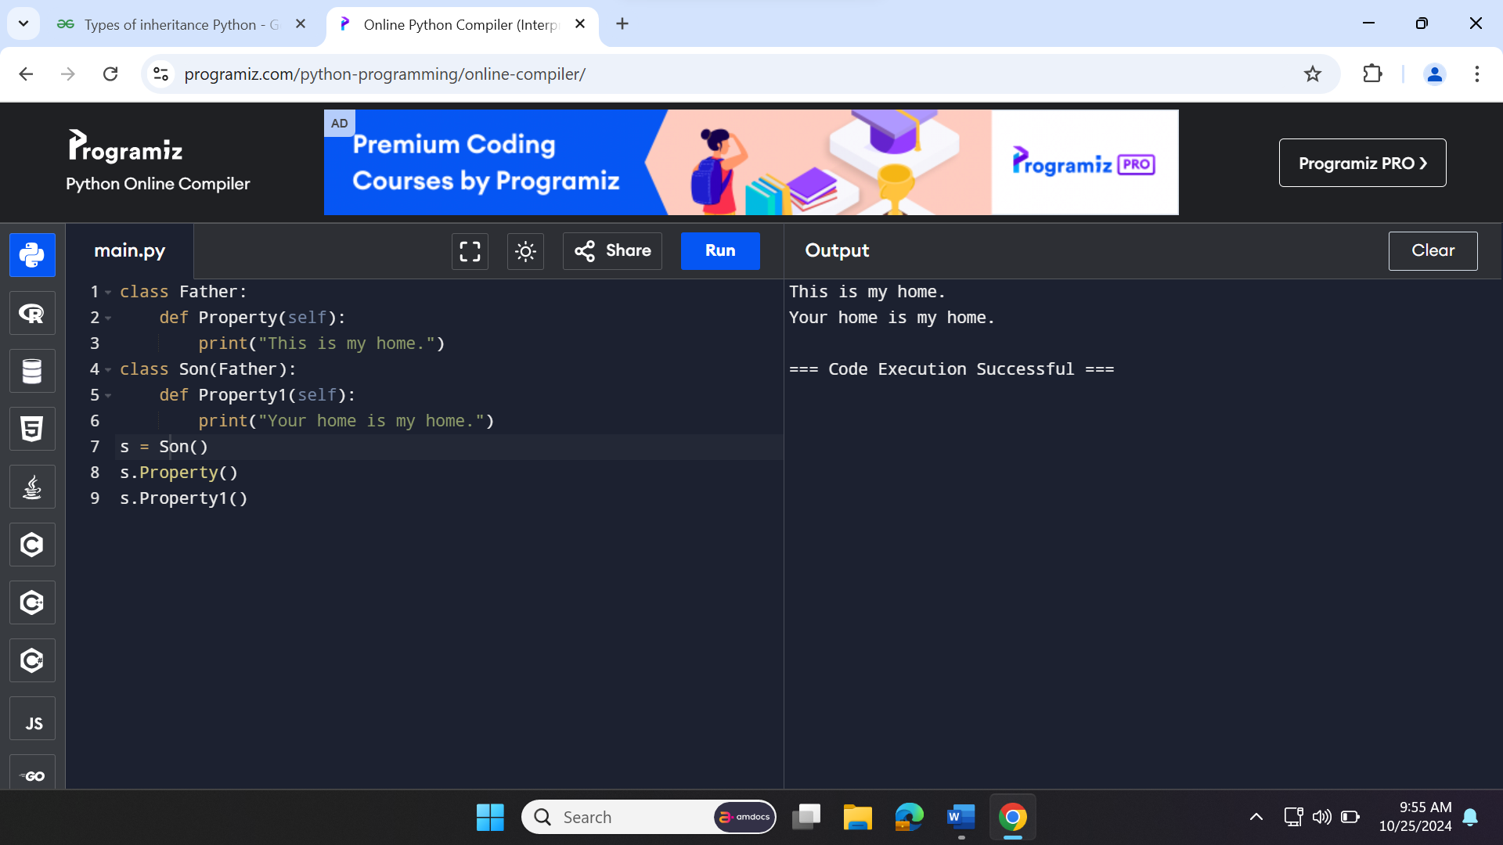

### ****Multiple Inheritance:****

When a class can be derived from more than one base class this type of inheritance is called multiple inheritances. In multiple inheritances, all the features of the base classes are inherited into the derived class.

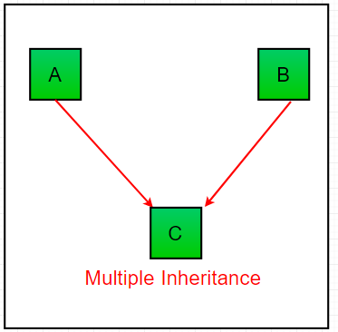

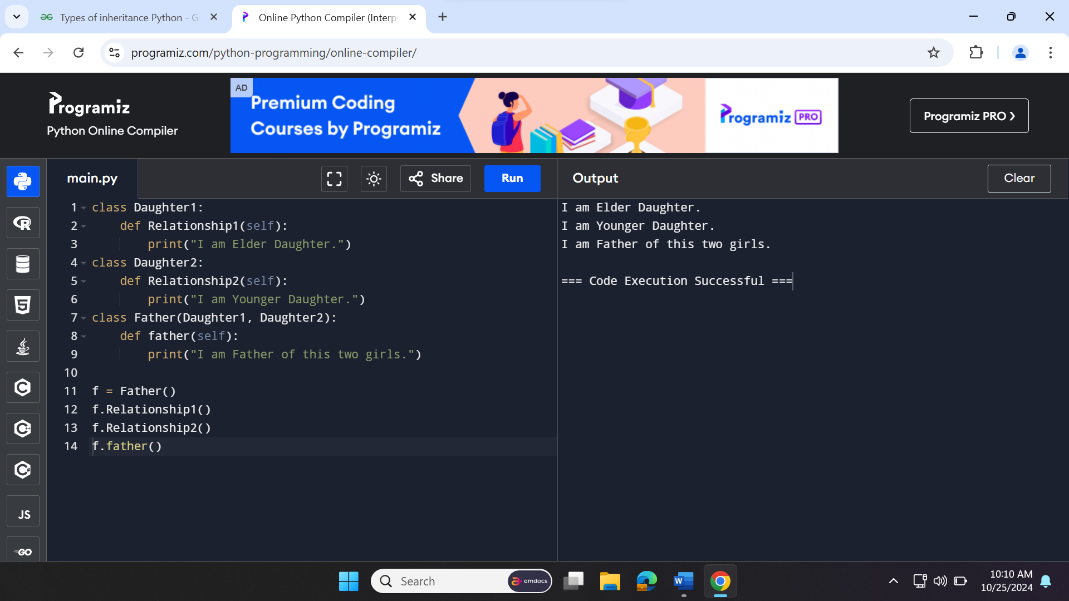

### ****Multilevel Inheritance**** :

In multilevel inheritance, features of the base class and the derived class are further inherited into the new derived class. This is similar to a relationship representing a child and a grandfather.

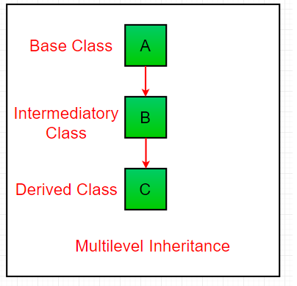

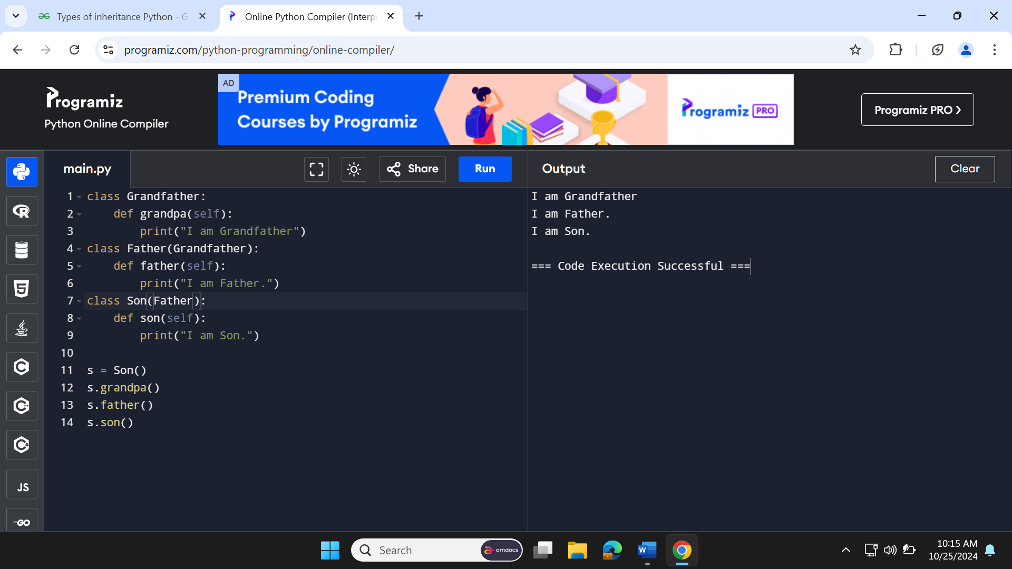

### ****Hierarchical Inheritance:****

When more than one derived class are created from a single base this type of inheritance is called hierarchical inheritance. In this program, we have a parent (base) class and two child (derived) classes.

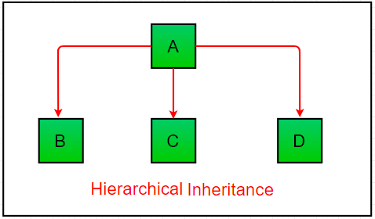

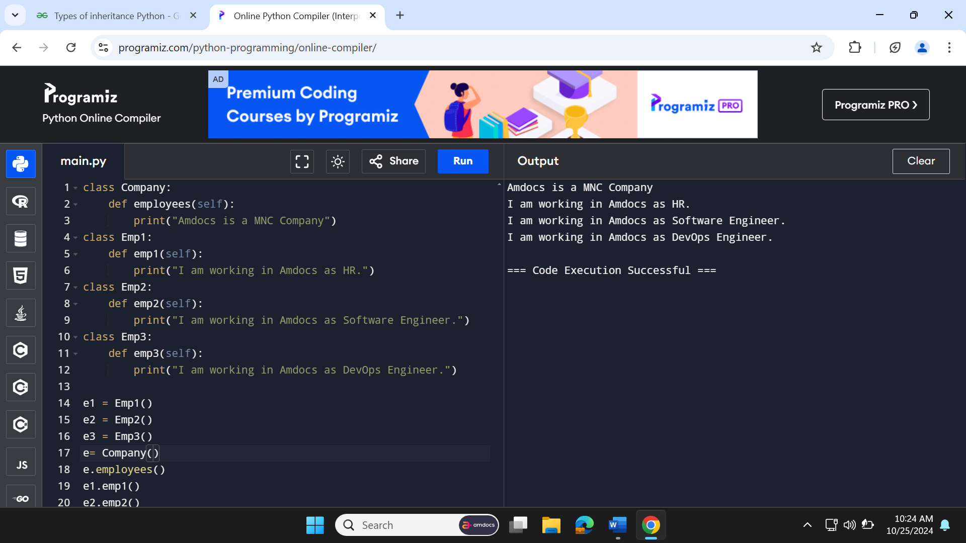

### ****Hybrid Inheritance:****

Inheritance consisting of multiple types of inheritance is called hybrid inheritance.

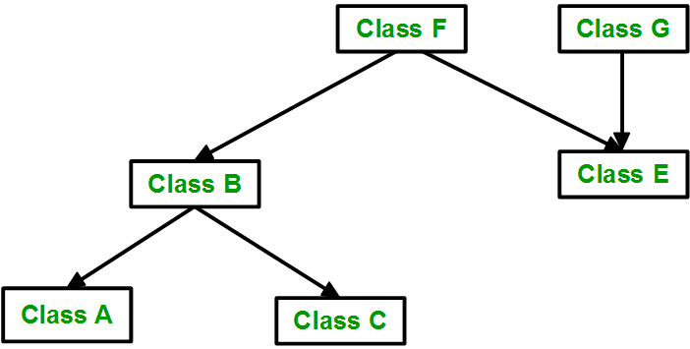

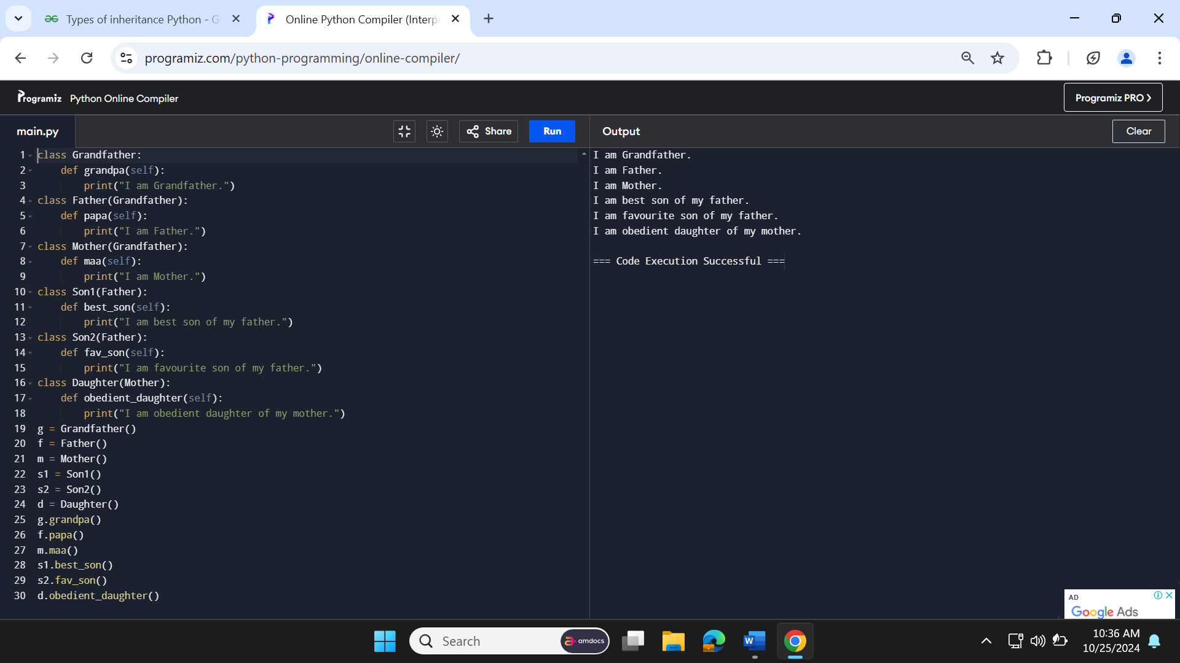

**Meta Characters**

**[] – Square Bracket**

[abc] – search for the char present in a square bracket

abc de ca – 5 matches

a – 1 match

Ac – 2 match

Hey Jude - No match

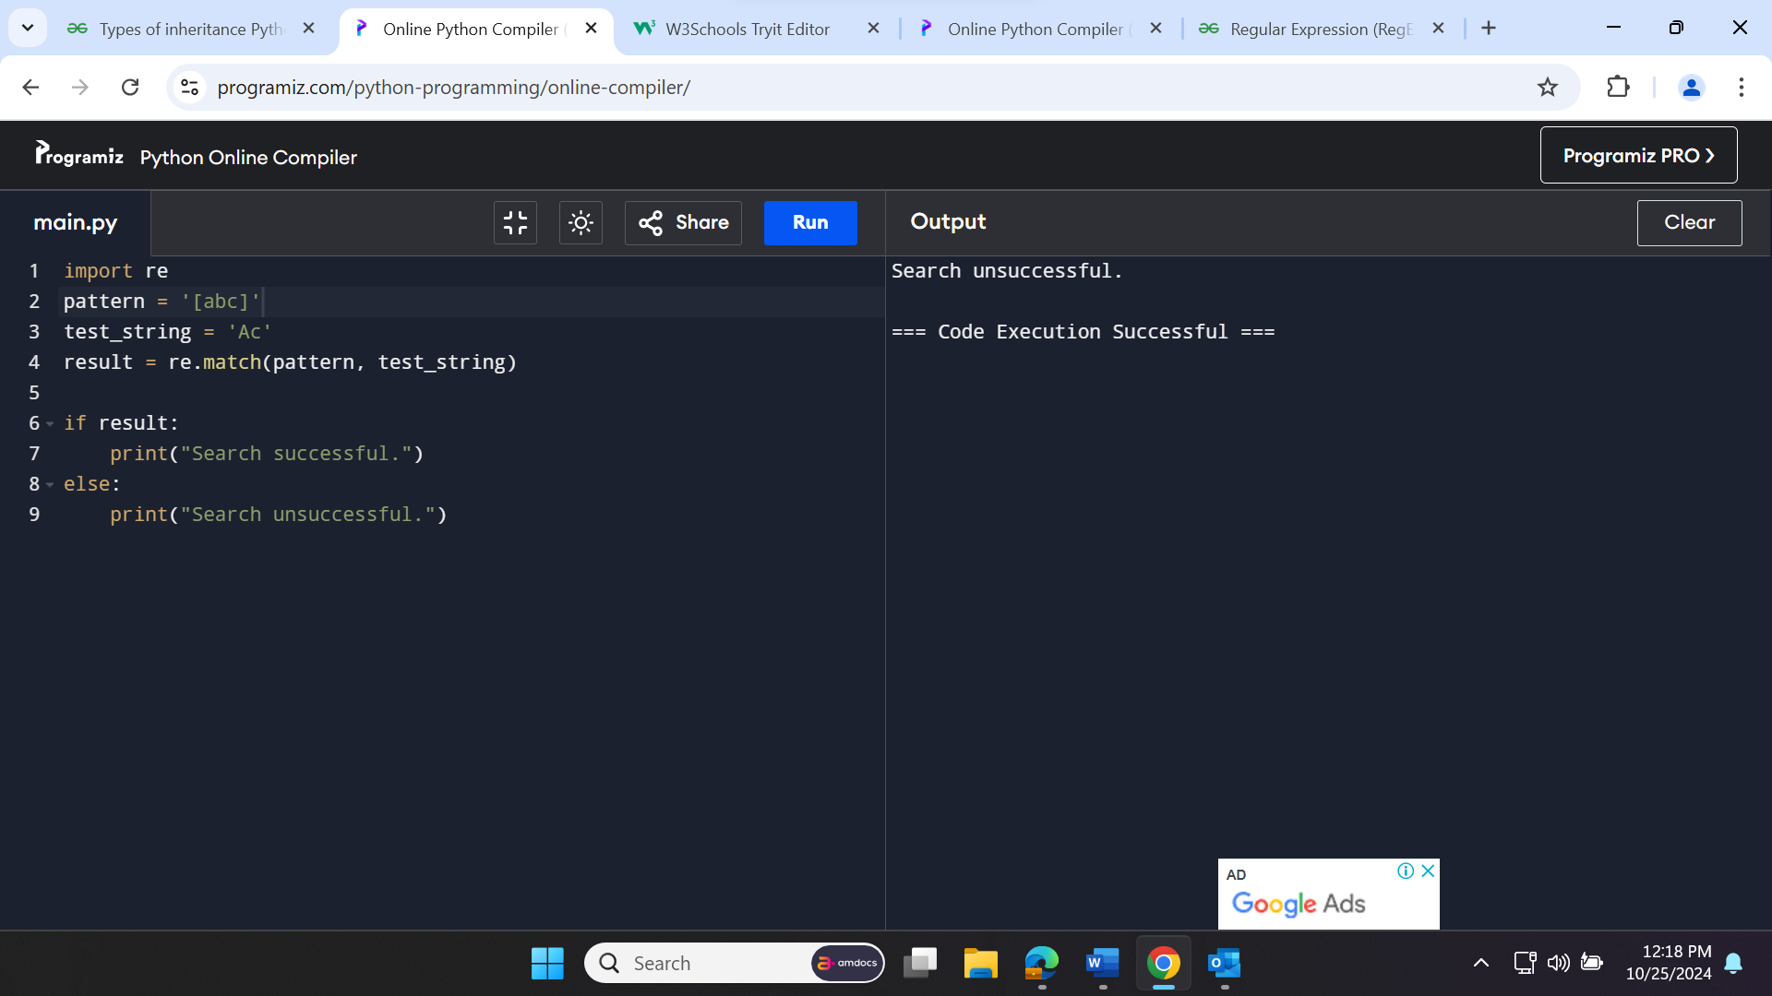

**^ - Caret**

The caret symbol ^ is used to check if a string starts with a chara

**$ - Dollar**

The dollar symbol is used to check if a string ends with a certain character.

a$

A – 1 match

Formula – 1 match

Cab – No match

**\* - Star (Zero or more)**

ma*n

mn – 1 match

man – 1 match

maaan – 1 match

main – No match (a is not followed by n)

woman – 1 match

**+ - Plus (One or more)**

ma+n

Mn – No match

man – 1 match

maaan – 1 match

main – No match (a is not followed by n)

woman – 1 match

**? – Question Mark**

The question mark symbol ? matches zero or one occurrence of the pattern left to it.

ma?n

Mn – 1 match

Man – 1 match

maan – No match (more than a character)

main – No match (a is not followed by n)

woman – 1 match

**{} – Braces**

Consider this code:{n, m}. This means at least n, and at most m repetitions of the pattern left to it.

a{2,3}

abc dat – No match

abc data – 1 match (at data)

aabc daaat – 2 matches (at aabc and daaat)

aabc daaaat – 2 matches ( at aabc and daaaat)

[0-9]{2,4}

ab123csde – 1 match ( match at ab123csde)

12 and 345673 – 3 matches (12, 3456, 73)

1 and 2 - No match

